HBAE Raid 2-3-4

HBAE Rules #1-3 apply, including:
2.1 The IHAA Raid Style consists of 6 runs: 2 runs of double, 2 runs of angled triple and 2 runs of serial shot (inc. short-track four shot)
2.1.1 The disciplines must be run in this prescribed order, i.e. double shot, angled triple then four shot.

6. R 2-3-4

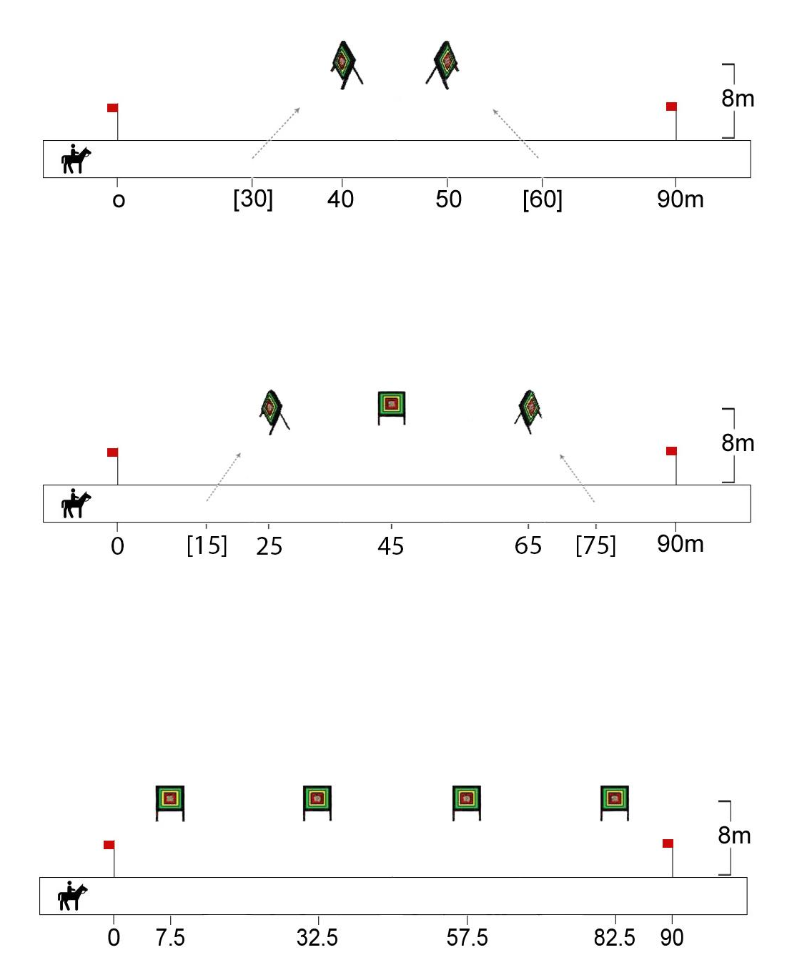 | Target face options:  - Round 80cm diameter target faces (FITA 80) @7m  - 80cm square faces @8m (as shown)  FITA 80 target faces @ 7m should be used in postal matches

6.1 Double Shot set up [as for the R233]
6.1.1 The course shall be 90m long.
6.1.2 Two targets shall be positioned as follows, for a front shot then back shot:
1 target at 40m along the track, angled to face the 30m point on the track;
1 target at 50m along the track, angled to face the 60m point on the track.
6.2 Double shot procedure
5.2.1 Competitors must not touch their arrows before passing through the start
5.2.2 The par time is 14s
5.3 Double shot scoring
6.3.1 Only 1 target hit is required to collect speed points
6.3.2 Multi-hit bonus: 2pts for hitting both targets

6.4 Angled Triple Shot set up [as for the R233]
6.4.1 The course shall be 90m long.
6.4.2 Three targets shall be positioned as follows, for front, side, then back shots:
1 target at 25m along the track, angled to face the 15m point on the track;
1 target at 45m along the track, angled for a sideways shot;
1 target at 65m along the track, angled to face the 75m point on the track.
6.5 Angled Triple Shot procedure
6.5.1 Competitors may start with an arrow nocked. The remaining arrows must be drawn from a quiver, belt or sash as usual.
6.5.2 The par time is 14s
6.6 Angled Triple Shot scoring. In a given run:
6.6.1 Speed points shall be awarded if two or more targets are hit
6.6.2 Multi-hit bonus: 3pts for hitting all three targets

6.7 Short-track Four Shot set up
6.7.1 The course shall be 90m long.
6.7.2 Four targets shall be positioned for sideways shots at distances of 7.5m, 32.5m, 57.5m and 82.5m along the track (ie. at 25m intervals).
6.8 Short-track Four Shot procedure
6.8.1 Competitors may start with an arrow nocked. The remaining arrows must be drawn from a quiver, belt or sash as usual.
6.8.2 The par time is 14s
6.9 Short-track Four Shot scoring. In a given run:
6.9.1 Speed points shall be awarded if two or more targets are hit
6.9.2 Multi-hit bonus: 4pts for hitting all four targets

SCORESHEET

